How to Test Project?
- API Documentation - Import the Request to POSTMAN
  - Create Your Own Req.
- Write the Testcases in the Excel
- Write the in Postman
- Execute in the Postman
- Report the Bugs -
- Test Report -> HTML Report
- Create Collection - Bunch of Request
- Import via
  - Manual Method
  - Curl
What is Curl?
- Commandline way to transfer the data (client to server) , No UI
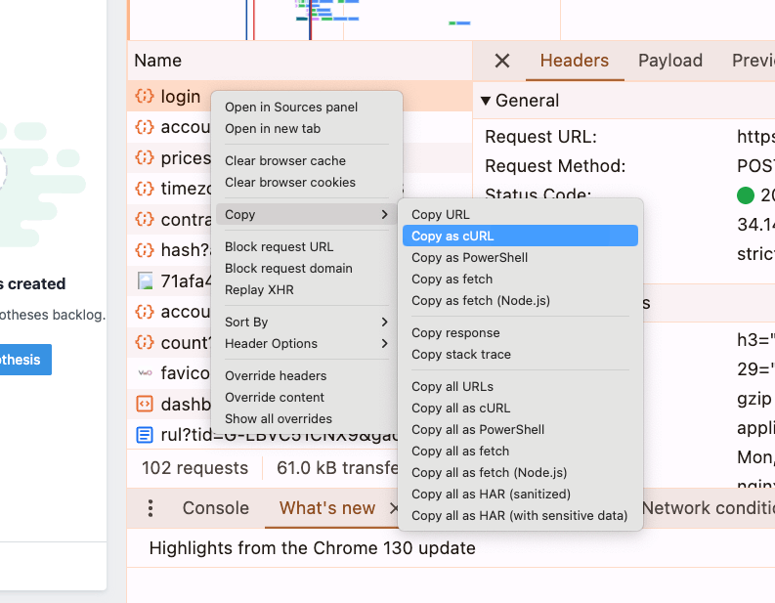

Test case writing of the Postman
Three ways to write
Super Easy - AI
- HTTP Status Code
- Time Validation
- Data Validation
- Schema Validation - JSON
- Token Not null, blank valication
- Headers
Disadvantages - It will make your dumb :)
Easy way - snippets
- Click on icon >. and add Snippets
Advance Way (Medium Level)
- Javascript Basics Learn
Test Execution Step by POSTMAN
- Run Collection
﻿restful-booker.herokuapp.com/apidoc/index.html#api-Ping-Ping
You can Generate the HTML Report
- Download and install the NODEJS - ﻿nodejs.org/en/download/prebuilt-installer
- In your CMD - node --version
  - v22.2.0
- npm --version
- npm -g install newman
- npm -g install newman-reporter-htmlextra
- newman run https://api.postman.com/collections/611814-39439594-ce19-46f5-8714-c5894c130321\?access_key\=PMAT-01JCYHR0C7RKM33F9CW0WFB49V -r cli,htmlextra

// Write the Test case by Own.
// POSTMAN - Says - TC - learn my Syntax -
pm.test();
chaiJS - framework (funtions). - Remember -

